**Pump Loop lab 6**

**Ratthamnoon Prakitpong**

**Hamayun Aziz #62064167**

**Arjun Vadehra #20037164**

**Summary**

The objective of this lab was to determine the performance of a centrifugal pump by analyzing pressure values at different points in a connected pipe. Pressure values, head values and other values were recorded and analyzed using standard Bernoulli theory and pump statistics.

**Procedure**

See mech 2 Lab manual.

**Results**

**RPS at 53**

|  |  |  |  |  |
| --- | --- | --- | --- | --- |
| **Volumetric flow (m^3/s)** | **Head (m)** | **Input Power (W)** | **Output Power (W)** | **Efficiency** |
| 0.00100944 | 3.541739113 | 58.771287 | 35.07244841 | 0.5967616195 |
| 0.00088326 | 3.824251377 | 52.223823 | 33.13629914 | 0.6345054275 |
| 0.00075708 | 4.117099455 | 49.205487 | 30.57751156 | 0.6214248334 |
| 0.0006309 | 4.341042103 | 45.732828 | 26.86726957 | 0.5874832314 |
| 0.00050472 | 4.771701042 | 39.896772 | 23.62613864 | 0.5921817093 |
| 0.00037854 | 4.875059188 | 34.954383 | 18.10342212 | 0.5179156536 |
| 0.00025236 | 5.012870048 | 32.018175 | 12.41011976 | 0.3875960999 |
| 0.00012618 | 4.92673826 | 28.765503 | 6.098443728 | 0.2120054611 |
| 0 | 0 | 0 | 0 | - |

*Table 1: Statistics for rps of 53*

**RPS at 43**

|  |  |  |  |  |
| --- | --- | --- | --- | --- |
| **Volumetric flow (m^3/s)** | **Head (m)** | **Input Power (W)** | **Output Power (W)** | **Efficiency** |
| 0.000788625 | 1.877672973 | 35.214375 | 14.52645031 | 0.4125147845 |
| 0.000690046875 | 1.981031119 | 32.9553 | 13.4103125 | 0.4069243036 |
| 0.00059146875 | 2.204973767 | 30.529383 | 12.79393789 | 0.4190696514 |
| 0.000492890625 | 2.46336913 | 27.848172 | 11.91102291 | 0.427712918 |
| 0.0003943125 | 2.497821845 | 25.236663 | 9.662088512 | 0.3828591962 |
| 0.000295734375 | 2.515048203 | 23.609592 | 7.296542704 | 0.3090499278 |
| 0.00019715625 | 2.549500918 | 20.2602 | 4.930996896 | 0.2433834264 |
| 0.000098578125 | 2.583953633 | 13.294488 | 2.498815995 | 0.1879587988 |
| 0 | 2.583953633 | 18.089103 | 0 | 0 |

*Table 1: Statistics for rps of 43*

**RPS at 33**

|  |  |  |  |  |
| --- | --- | --- | --- | --- |
| **Volumetric flow (m^3/s)** | **Head (m)** | **Input Power (W)** | **Output Power (W)** | **Efficiency** |
| 0.00056781 | 1.119713241 | 19.759092 | 6.237044722 | 0.3156544199 |
| 0.00051260625 | 1.378108604 | 18.139572 | 6.930049691 | 0.3820404192 |
| 0.0004574025 | 1.48146675 | 16.899432 | 6.647516896 | 0.3933574156 |
| 0.00040219875 | 1.533145822 | 15.9708 | 6.049133759 | 0.3787621008 |
| 0.000346995 | 1.75708847 | 15.783207 | 5.981165964 | 0.3789575822 |
| 0.00029179125 | 1.877672973 | 14.661288 | 5.374786616 | 0.366597165 |
| 0.0002365875 | 1.929352046 | 14.286192 | 4.477878262 | 0.3134409969 |
| 0.00018138375 | 1.860446616 | 12.779175 | 3.31043143 | 0.2590489159 |
| 0.00012618 | 1.998257476 | 12.451383 | 2.473494659 | 0.1986522027 |
| 0 | 1.929352046 | 11.019447 | 0 | 0 |

*Table 1: Statistics for rps of 33*

**Plot for different speeds**

* **Rps at 53**

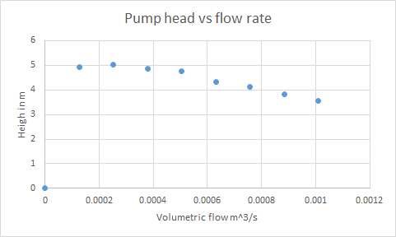

*Figure 1: Head vs flow rate*

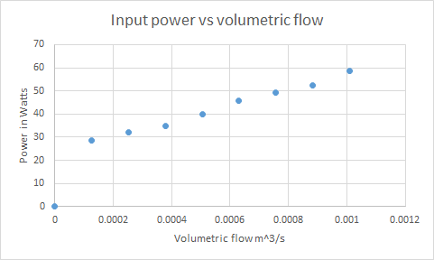

*Figure 2: Input power vs flow rate*

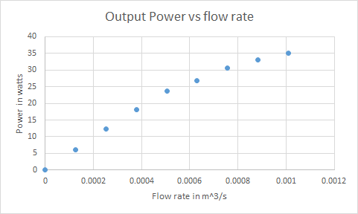

*Figure 3: Output Power vs flow rate*

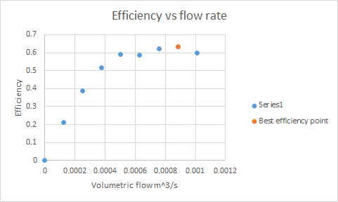

*Figure 4: Efficiency vs flow rate*

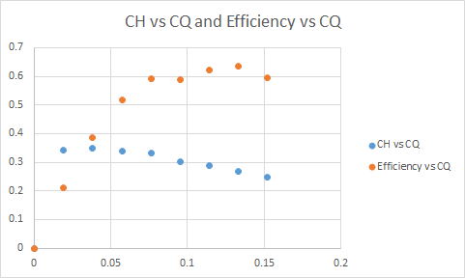

*Figure 5: Non Dimensional plots 53 rps*

**Rps at 43**

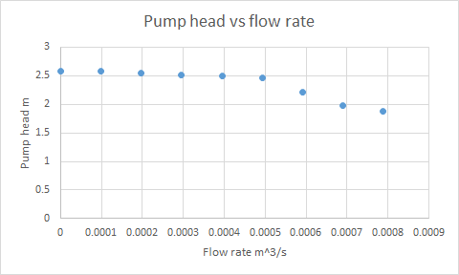

*Figure 6: Pump head vs flow rate*

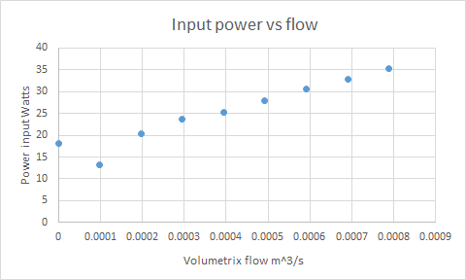

*Figure 7: Input power vs flow rate*

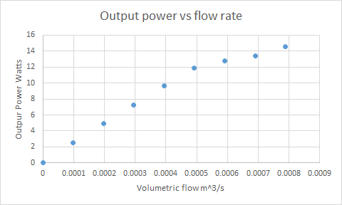

*Figure 8: Output power vs flow rate*

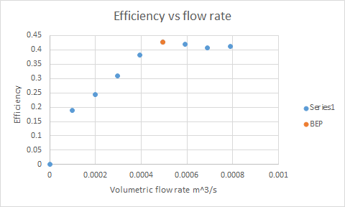

*Figure 9: Efficiency vs flow rate*

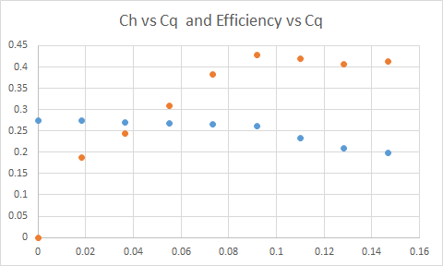

*Figure 10: Non-dimensional plots 43 rps*

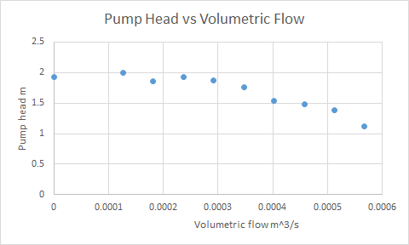

*Figure 11: Pump Head vs Volumetric Flow*

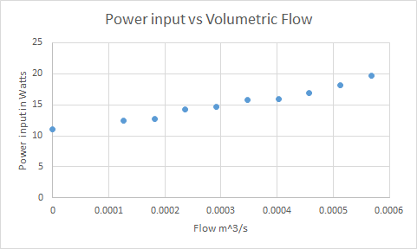

*Figure 12: Power input vs Volumetric Flow*

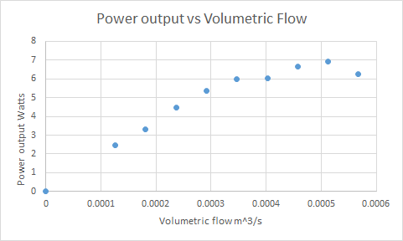

*Figure 13: Power output vs volumetric flow*

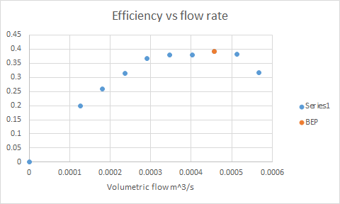

*Figure 14: Efficiency vs flow rate*

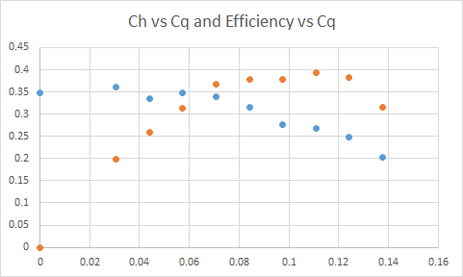

*Figure 15: Non-dimensional plots 33 rps*

**Comments**

* Although using the simplified Bernoulli equation pump head does not depend on volumetric flow rate, however with increasing flow there is an increase in frictional effects which corresponds to the decrease in pump head.
* Pump head follows the same behaviour for each motor rotation speed however the plot begins from a lower head for each decrease in motor speed.
* Power input and output increase to overcome the increasing friction and electrical losses.
* The decrease in motor speed for each set of data means that the pump is adding lesser maximum power input and output.
* Best efficiency points have been identified for each motor speed.